Assignment 15 (January 23 – 28)

1. Find the maximizer of 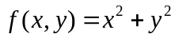, subject to the constraints 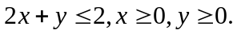

2. Solve Bernoulli equation, definitize the arbitrary constant:
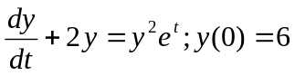
3. Show that the function
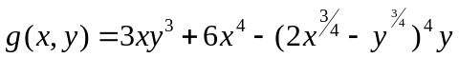
is homogeneous. Verify Euler's Theorem for g.

4. Verify that each of the following differential equation is exact, and solve it by step-by-step procedure:
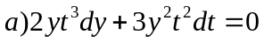
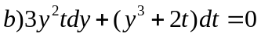
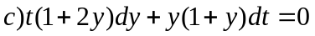

5. Solve the following first-order differential equations :
